

Faculty of Computer Science & Computer Engineering

Department of Computer Science

BSc Hons in Computer Networks & Cyber security

Continuous Assessment

Subject Name: Data Science
Subject Code: COM4302
Title: Mini Data Science Project
Batch: 08
Student ID: 11192
Deadline of the Assignment: 17/03/2026
Submission Date of the Assignment: 17/03/2026
Table of Contents
1 Introduction 2
1.1 Problem Formulation 2
1.2 Data Acquisition 2
2 Data Analysis 3
2.1 2.1 Clean and Preprocess Data 3
2.2 Exploratory Data Analysis (EDA) 3
3 ML / AI Methods 6
3.1 Logistic Regression 7
3.2 Decision Tree Classifier 7
3.3 Random Forest Classifier 8
4 Reflection 8
5 Conclusion 9
6 References 9

A predictive model of Customer Purchase Behavior through machine learning in E-Commerce Systems.

Introduction
Knowledge of customer behavior is also relevant when it comes to sales and marketing in the context of the contemporary e-commerce. The online platforms gather information about the activity on the web, the history of purchases and the customer interaction. With the help of machine learning, businesses can discover trends and determine whether a customer will purchase a product or not using this information. The given project is devoted to the data science and predictive model analysis to discuss the customer behavior and identify the main factors, that is, which influence the purchasing behavior.

Problem Formulation
Conventional marketing practices are usually based on sweeping generalizations concerning customer behavior. Nonetheless, the decisions when buying a product depend on a combination of various factors including income level, a customer when browsing, loyalty programs, and customer engagement. This project is a data-driven project since it:
- Examining buying behavior and behavioral demographics of customers.
- Creation of predictive models to categorize whether customer will go through a purchase or not.
Research Question
What customer information, behavior and interaction variables affect online product purchase?

Data Acquisition
Origin: Public Kaggle dataset – Customer Purchase Behavior Dataset (E-Commerce).
It has half a million records of the customer activity in an online shopping platform, including demographics and engagement metrics, shopping behavior and satisfaction indicators.
The data contain 17 variables
1 = Customer made a purchase
0 = Customer failed to make a purchase.
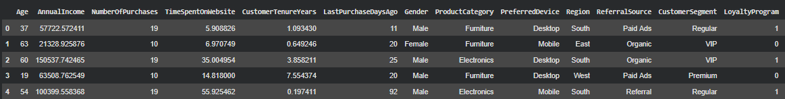
The dataset is appropriate in the analysis of customer purchasing behavior and making purchase decisions.

Data Analysis

2.1 Clean and Preprocess Data
There were a number of pre-processing steps that were used to achieve data quality and consistency. Ste
Step | Pre-processing Task | Description
1 | Remove Unnecessary Columns | The dataset was checked for unnecessary columns that do not contribute to predictive modeling. All variables included in the dataset provide meaningful information about customer behavior.
2 | Handle Missing Values | Missing values on all the variables were analyzed on the dataset. There were no major missing values. Any possible missing values were substituted with corresponding values to ensure that the model is stable.
3 | Encode Categorical Variables | The other variables, Gender, ProductCategory, PreferredDevice, Region, ReferralSource and CustomerSegment were coded with label encoding so as to be turned into numbers that can be used in machine learning algorithms.
4 | Remove Duplicates | There were duplicate records which were confirmed and deleted to ensure the integrity of the databases. The preprocessed data was now available to undergo exploratory data analysis and machine learning modeling.

Exploratory Data Analysis (EDA)
EDA was done to discover patterns and relationship between customers characteristics and buying behavior.
- Purchase Status Distribution.
Target variable distribution shows the number of customers who made purchases and those that did not.
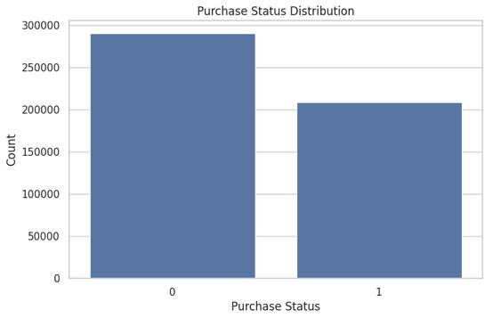

(Figure 1: Purchase Status Distribution)

- Age Distribution

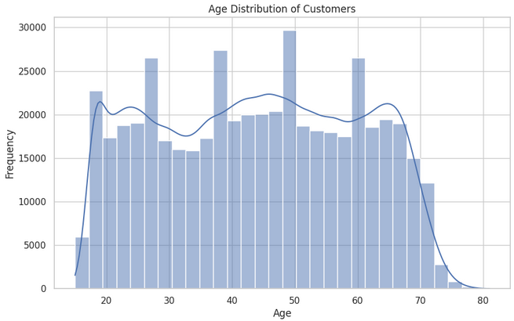

(Figure 2: Age Distribution Histogram)

- Income vs Purchase Status
An analysis of the box-plot indicates that customers who have higher levels of annual income would purchase the products more often, but there is not a significant difference between the two groups.
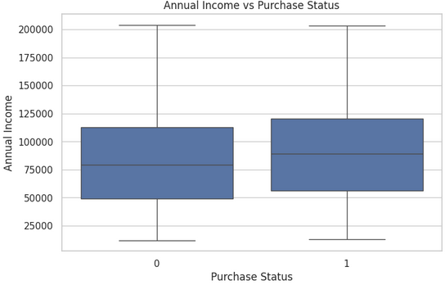
(Figure 3: Income vs Purchase Boxplot)

- Time Spent on Website
Customers who have taken a longer time to browse through the website have a high likelihood of making a purchase.
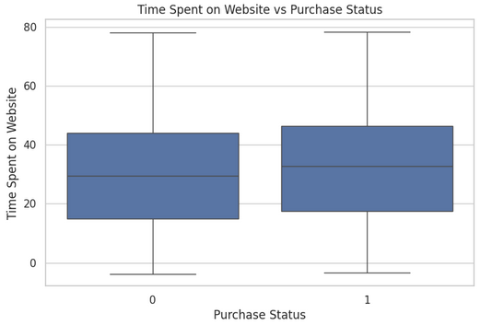

(Figure 4: Time Spent on Website Distribution)

- Correlation Analysis
A heatmap correlation was created to explore the associations between the variables of customer behavior and purchase results.
The bulk of the variables present moderate correlations with the target variable, which demonstrates that customer purchase behavior is determined by a number of interacting variables, as opposed to a dominant feature.
The engagement variables, which include the number of sessions, number of purchases and time spent on the site have stronger correlations with the purchase behavior.
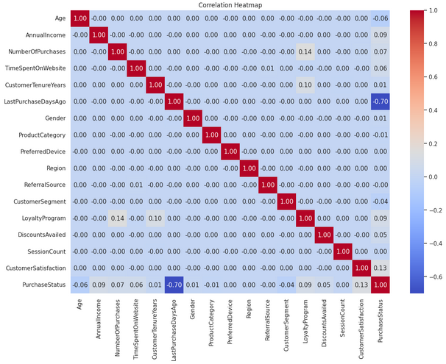

Figure 5: Correlation Heatmap
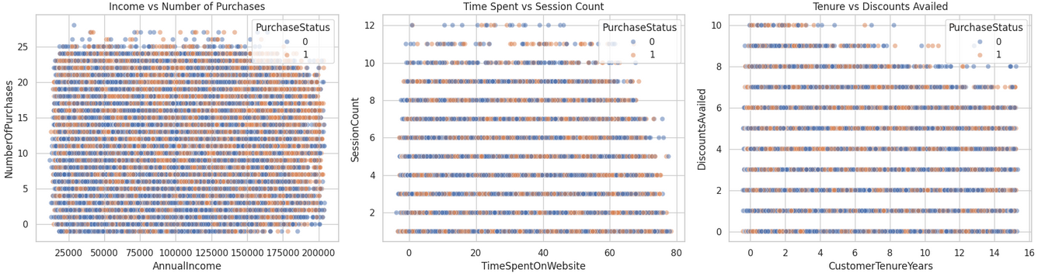
Figure 6: Scatter Plot

ML / AI Methods
The predictor variables in this study were Age, AnnualIncome, NumberOfPurchases, TimeSpentOnWebsite, CustomerTenureYears, LastPurchaseDaysAgo, Gender, ProductCategory, PreferredDevice, Region, ReferralSource, CustomerSegment, LoyaltyProgram, DiscountsAvailed, SessionCount and CustomerSatisfaction. These characteristics are the customer demographic, customer behaviour and engagement variables that could influence the purchasing decisions.
PurchaseStatus an indicator of whether a customer purchased or not (1 = Yes, 0 = No), was the target variable.
The dataset had several variables of numerical variables and encoded categorical variables that were suitable in machine learning classification models. The model was tested using the randomly selected 70 percent training data and the 30 percent testing data.
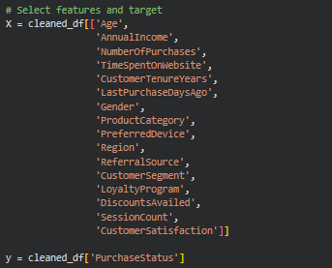
Figure 7: Feature Selection

Logistic Regression
The accuracy of the Logistic Regression model was 0.9226, which implies that the model was very precise and made 92.26 predictions accurately. The model had a precision of 0.8945 and a recall of 0.9299, which is the high level of success in recognizing customers that likely make purchases. Precision and recall do not show bias as the F1-score of 0.9092 is balanced.
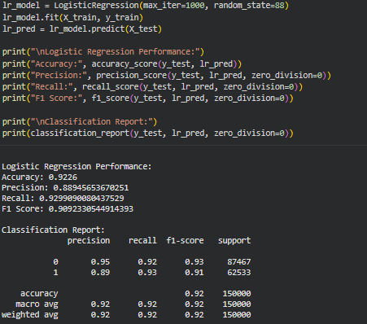
Figure 8: Logistic Regression Model

Decision Tree Classifier
The Decision Tree model had an accuracy of 0.8877 which is a little lower as compared to the other models. The model generated a precision of 0.8679 and recall of 0.8617 and an F1-score of 0.8649. Decision Trees have the capability to infer nonlinear relationships but in comparison with ensemble models, it may be more susceptible to overfitting.
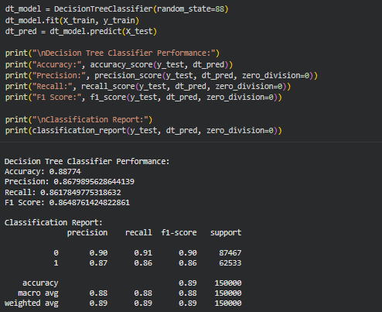
Figure 9: Decision Tree Model

Random Forest Classifier
Random Forest classifier was the most successful model as it had the highest accuracy of 0.9238. The accuracy of the model was 0.9051, recall was 0.9319 and F1-score was 0.9107. The grouping characteristic of the Random Forest enables it to model complex interactions among customer behavioral characteristics and therefore it is the most useful model to use with this data.
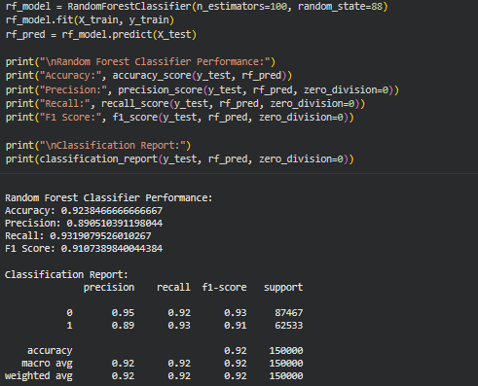
Figure 10: Random Forest Model

Reflection
Challenges Faced
- Huge amount of data which needs to be preprocessed effectively.
- Encoding various categorical variables.
- Possible unequal buying behavior in classes.
Key Learnings
- Purchasing decisions highly depend on customer engagement metrics including the number of visits and the duration (time) on the site.
- Promotions and customer loyalty programs would have a great impact on buying likelihood.
- Machine learning models have the ability to locate concealed trends in customer behaviour that conventional analysis could not recognize.

Table 1: Model Performance Comparison
Metric | Logistic Regression | Decision Tree | Random Forest | Best Performer
Accuracy | 0.9226 | 0.8877 | 0.9238 | Random Forest
Precision | 0.8945 | 0.8679 | 0.9051 | Random Forest
Recall | 0.9299 | 0.8617 | 0.9319 | Random Forest
F1 Score | 0.9092 | 0.8649 | 0.9107 | Random Forest

Conclusion
Random Forest classifier proved to be the best in terms of overall performance with the highest values of accuracy, precision, recall, and F1-score. It means that the ensemble learning techniques are very much efficient in identifying complicated trends in customer behavior and forecasting purchase behaviors in massive e-commerce data sets.

References

[1] | F. Chollet, "Deep Learning with Python.," Manning Publications., 2018.
[2] | A. Géron, "Hands-On Machine Learning with Scikit-Learn, Keras & TensorFlow.," O’Reilly Media., 2023.
[3] | W. McKinney, "Python for Data Analysis.," O’Reilly Media., 2022.
[4] | J. VanderPlas, "Python Data Science Handbook.," O’Reilly Media., 2017.

Data set link : https://www.kaggle.com/datasets/gauthamvijayaraj/customer-purchase-behavior-dataset-e-commerce

GitHub repository link:

